# CIS-2225 Assignment 1

You will need to build an application that accepts the course name, course grade in a numeric form and determines the corresponding letter grade for the numeric grade. You will need to track how many courses have been entered and keep a running sum of the grade values.

I have provided you with the starting code. You do not need to change the layout of the form.

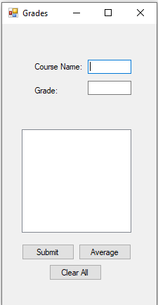

## Form tasks

1. Rename the form to frmMain
2. Set the text property of the form to Grades
3. Name all the controls correctly
4. Fix the tabbing order. It should be Course Name text box – Grade text box – Submit button – Average button – Clear All button. Don’t allow the tabbing to enter the list box.

## Global variables

You will need to create global variables to keep count of how many courses have been entered and a running sum of all the grades. These will be used by the Average button.

## Submit button click event

When the submit button is clicked you need to validate the data entered. You need to make sure the input for course name is not empty and make sure the input for grade can be parsed to a double and is not less than 0.

If the course name is empty show a message box that says, "Please enter a course name." put focus on the course name text box and return to the form.

If course name is not empty, then check the grade text box to see if it can be parsed to a double and is not less than 0. If either are true show a message box that says "Please enter a grade as a number and not less than 0" put focus on the grade text box and return to the form.

If both conditions pass then you need to determine the grade letter for the grade number entered. You can use the following to determine the grade letter

if grade entered is greater than 89 then grade letter is A

if grade entered is greater than 79 and less than 90 grade letter is B

if grade entered is greater than 69 and less than 80 then grade letter is C

if grade entered is greater than 59 and less than 7 0then grade letter is D

59 and lower grade letter is an F

You should create a method that accepts the numeric grade number as a parameter and returns the grade letter.

Once you determine the grade letter you need to add the course name – grade number – grade letter to the list box.

After the grade information has been added to the list box clear the course name and grade text boxes.

|  |  |
| --- | --- |
|  |  |
|  |  |

## Average button click event

When the Average button is clicked it will calculate the average grade of all courses entered so far and will determine the correct grade letter based on the options above. It will then show a message box saying "Average grade for total courses is grade letter"

You will use the global variables you created to count the number of courses and sum the grade values to get the numeric grade. Then use the same guide from above to determine the letter grade.

## Clear All button click event

When the Clear All button is clicked it will clear the text boxes, list box and running total global variables.

## Comments

Add a header comment with author, date, class, and description to the top of your code.

Add inline comments where you code is not easily understood.